
DAWOOD UNIVERSITY OF ENGINEERING AND TECHNOLOGY
Faculty of Information and Computer Science
Department of Computer Science

MaintainIQ
Software Maintenance Cost Estimator
A Flutter Mobile Application Using the COCOMO II Mathematical Model

Team Members  Faizan Ali 24F-CS-044  Rayyan Hussain 24F-CS-047  Areej 24F-CS-048  Bushra Waseem 24F-CS-049 | Submitted To  Dr. Fida Hussain Khoso  Course: Software Engineering  Program: BS Computer Science  Submission Date: 27 April 2026

Table of Contents

1.0 Abstract | 3
2.0 Introduction | 4
3.0 Problem Statement | 5
4.0 Objectives | 6
5.0 Project Significance & Contribution | 7
6.0 Literature Review | 8-9
7.0 Methodology | 10-11
8.0 System Architecture | 12
9.0 Application Screens & UI Overview | 13
9.1 Splash Screen | 13
9.2 Login Screen | 14
9.3 Sign Up Screen | 15
9.4 Home Dashboard | 15-16
9.5 History Screen | 16-17
9.6 AI Chatbot Screen | 17-18
9.7 Insights Screen | 19-20
9.8 PDF Reports Screen | 21
9.9 Estimation Results Screen | 22
9.10 Profile Screen | 23
9.11 PDF Report | 24
10.0 Architecture Diagram | 25-26
11.0 Use Case Diagram | 27-28
12.0 Folder Structure | 29-31
13.0 Core Features | 32-33
14.0 COCOMO II Formula & Calculations | 34
15.0 Software Quality Assurance | 35
16.0 Limitations | 36
17.0 Conclusion | 37
18.0 Future Work | 38
References | 39

1.0 Abstract
Software systems, once built, do not run themselves. They require constant attention, fixing bugs, applying security patches, updating dependencies, and adapting to new requirements. This is an ongoing work, and it is becoming more expensive every year. But most organizations ignore this cost or estimate it by gut feeling until the budget runs out.

That's the problem MaintainIQ was created to solve. It is a mobile application based on Flutter that uses COCOMO II (Constructive Cost Model II) to provide year-by-year maintenance cost projections for any software system. A project manager enters basic details about their software: how big it is, how old, how complex, and how much it originally cost to build, and the app returns a detailed cost breakdown for the next five or more years, with a clear recommendation: continue maintaining, refactor to reduce costs, or cut losses and rebuild.

Beyond the core calculator, MaintainIQ has a Grok AI chatbot for guidance, Firebase-backed history to ensure estimates are never lost, USD and PKR currency support, and professional PDF report export. This application has been developed as a software engineering project by Group 13 of Dawood University of Engineering and Technology (DUET). It demonstrates applied skills in mobile development, mathematical modeling, cloud integration, and AI-assisted software tools.

Keywords: Software Maintenance, COCOMO II, Cost Estimation, Flutter, Firebase, AI Chatbot, Grok AI, Technical Debt, Software Lifecycle, Mobile Application

2.0 Introduction
Every software project follows the same arc. A team builds something, ships it, and then almost immediately starts maintaining it. Features need updating. Bugs need fixing. Libraries go out of date. Security vulnerabilities appear. What nobody tells you when you are in the excitement of building something new is that this maintenance phase typically lasts much longer than development itself, and it costs significantly more over time.

Research in software engineering has consistently shown that maintenance accounts for 60 to 80 percent of total software lifecycle costs. Despite this, most teams enter the maintenance phase with no real financial plan. They estimate informally, react to problems as they come, and routinely underestimate how costs will compound as the system gets older and more complex.

MaintainIQ was developed to address this gap directly. The application implements the COCOMO II framework, one of the most well-validated software cost estimation models in the field, and makes it accessible through a clean, user-friendly mobile interface. Users do not need a background in software cost engineering to use it. They enter what they know about their software, and MaintainIQ does the math.

The application was built using Flutter and Dart for the mobile frontend, Firebase for authentication and cloud storage, and Grok AI for an integrated conversational assistant. It targets software developers, project managers, students, and anyone responsible for making financial decisions about software systems.

This report documents the full development process from the problem that motivated the project through the technical architecture, the core algorithm, the user interface screens, system diagrams, results from testing, and the directions the project could take in the future.

3.0 Problem Statement
Software maintenance accounts for the largest budget in any technology organization—yet it’s one of the least regularly planned for budgets. Maintenance cost estimating tools are woefully inaccurate, leading organizations large and small into operational inefficiencies and financial hardships.

When organizations can’t predict their costs for maintaining software, several predictable problems result:

- Budgets are routinely exceeded because maintenance was never accurately estimated. Developers run out of money mid-maintenance cycle and must postpone critical fixes.
- Security patches are left unfixed on systems that have exhausted their maintenance budgets, posing security risks that cost much more than adequate maintenance would have.
- Technical debt spirals out of control. When budgets are insufficient for maintenance, developers cut corners. Those corners exponentially increase the cost of future maintenance.
- Leaders are forced to make critical business decisions without data. How can a leader know whether to keep maintaining a system or start fresh if they don’t know what one option will cost over the next five years compared to the other?
- Outdated systems continue to drain the budget. Once software should have been replaced or rebuilt years ago, but the business case was never established because nobody could accurately estimate those costs.

MaintainIQ solves each of these problems by empowering users with the single thing they lack right now: accurate predictions of how much their software will cost to maintain each year into the future.

4.0 Objectives
This project had six clear goals:

1. Use the COCOMO II model as the main calculation engine, so maintenance cost estimates are reliable and up to industry standards.

2. Give year-by-year cost projections for at least five years, so organizations can actually plan ahead and see what’s coming financially.

3. Sort maintenance health into categories—Healthy, High Cost, or Critical—and offer real advice based on how the costs stack up against development expenses.

4. Add an AI chatbot (Grok AI) to help users understand their results, make sense of the recommendations, and figure out how to use the app.

5. Set up secure cloud storage with Firebase for user logins and to save all previous estimates.

6. Make it easy to generate polished PDF reports, so users can share their maintenance analysis with whoever needs to see it.

5.0 Project Significance & Contribution

5.1 Filling a Real Gap

Most software cost estimation tools just don’t fit what people actually need. On one side, you have heavyd uty enterprise systems like IBM Rational and high-priced consulting services. Sure, they do the job, but you’ll need deep pockets, specialized training, and a level of organizational maturity that most teams especially those in academia or startups simply don’t have. On the other side, you get bare-bones tools like spreadsheets or advice from random blog posts. Easy to use, but honestly, there’s not much rigor there.

This is where MaintainIQ comes in. It finds the sweet spot in the middle. It’s free, works right from your mobile device, and doesn’t demand any special training. Yet, it still bases its estimates on the same mathematical models the pros use. No other tool offers that particular mix right now.

5.2 Industry-Standard Methodology

Instead of inventing its own estimation method, MaintainIQ relies on COCOMO II. That matters. When someone asks why maintaining your system will cost three times what it took to build, your answer isn’t just, “Well, that’s what the tool spits out.” You can point to COCOMO II a model that’s been thoroughly validated with thousands of real software projects over the years. That sort of credibility actually impacts decisions inside organizations.

5.3 Educational Value
For students and junior engineers, MaintainIQ turns all those abstract cost modeling concepts into something you can really see and play with. Things like age factors, penalties for technical debt, and size multipliers stop being vague theory once you start plugging in numbers and watching how costs shift. Plus, MaintainIQ itself is a great example of how you can blend Flutter, Firebase, AI APIs, and mathematical modeling into a real, working app. That’s a lesson in itself.

6.0 Literature Review

6.1 The COCOMO II Model
Back in 1981, Barry Boehm came up with the original COCOMO model to help people estimate how much time and money they’d need to build software, just by looking at the project size and a few cost drivers. Fast forward to 2000 COCOMO II showed up, completely rebuilt for the way we write code now: object-oriented design, reusing components, spiral development, and buying more solutions off the shelf. Researchers still reference it all the time, and it still gets used in software cost studies.COCOMO II’s main idea is simple: software costs aren’t just guesswork. They actually follow patterns you can measure. If you’re working on a bigger system, you’ll spend more period. Older code costs more to keep going than newer code. The more technical debt you have, the more you pay for it in maintenance. COCOMO II turns these concepts into math using real data from hundreds of projects, so you’re not just relying on gut feelings.

6.2 The Economics of Software Maintenance

It’s a standard fact now thanks to Pigoski in 1996 that maintaining software eats up 60 to 80 percent of what you spend over its whole life. And Lehman, even earlier, pointed out that you can’t just write software and leave it alone. The world changes, software has to keep up, and if you stop tending to it, it only gets messier and trickier to fix. That’s why maintenance costs keep climbing. This is exactly what MaintainIQ’s age factor and technical debt weights are about they just put hard numbers on those realities.

6.3 Flutter as a Development Platform

Google rolled out Flutter in 2018. You write your app once, in Dart, and it spits out native code that runs efficiently on both Android and iOS. Features like hot reload make it easy to test changes instantly, and the widget system makes UI development smoother than most. With a tight four-person team and only a semester to get things done, Flutter was just the practical way to go. Plus, since it renders everything itself, you don’t have to worry every chart, table, and screen looks right, no matter what device you’re holding.

6.4 Firebase for Backend Services

Firebase offers Authentication, Cloud Firestore, and Cloud Messaging as managed services with a generous free tier. For a project of this scope, Firebase streamlines backend infrastructure, enabling the team to focus on application logic and user experience. Firestore’s real-time synchronization ensures estimate history is instantly accessible across sessions.

Estimate history is instantly accessible across sessions, crucial for maintaining consistency and providing users with the most up-to-date information without manual updates. By using Firebase, MaintainIQ can ensure a seamless user experience, allowing users to access their latest estimates at any time, enhancing productivity and efficiency.

6.5 Grok AI Integration
Integrating Google Grok as the AI chatbot backend into MaintainIQ enables the application to offer intelligent, adaptive guidance on COCOMO II concepts, interpreting results, and answering maintenance-related questions in both English and Urdu. This integration elevates MaintainIQ beyond a simple calculator, positioning it as an intelligent decision-support tool, providing users with valuable insights and support in managing their maintenance processes.
7.0 Methodology

7.1 Core Formula
MaintainIQ implements a COCOMO II-derived formula for annual maintenance cost:

Annual Cost = DevCost × BaseRate × SizeFactor × AgeFactor × Inflation

Parameter | Formula / Values | Explanation
BaseRate | 15% + (Complexity × 2.5%) + (TechDebt × 3%) | Higher complexity and technical debt increase the annual maintenance percentage of the development cost.
AgeFactor | 1.0 + (Age × 0.04) per year | Older software costs 4% more per year to maintain. A system 10 years old costs 40% more than a new one.
SizeFactor | Small=1.0 / Medium=1.3 / Large=1.6 / Enterprise=2.0 | Larger systems have more components and more surface area for failures. Enterprise systems require the most maintenance effort.
Inflation | 3% compounded per year | Labour and infrastructure costs increase annually. This factor captures the economic reality of year-on-year inflation.

7.2 Health Classification
Once the total projected cost is calculated, MaintainIQ compares it against the original development cost and assigns a health status:

Status | Condition | Recommended Action
🟢 Healthy | Total cost < 1.5× dev cost | Continue standard maintenance. Budget is within sustainable range.
🟡 High Cost | Total cost 1.5× to 3× dev cost | Refactor to reduce technical debt. Review architecture before costs escalate further.
🔴 Critical | Total cost > 3× dev cost | Rebuilding the system is likely more economical than continued maintenance. Evaluate options immediately.

8.0 System Architecture

8.1 Technology Stack
Layer | Technology | Role
Mobile Frontend | Flutter & Dart | Cross-platform UI for Android. Reactive widget model with Provider state management.
Authentication | Firebase Auth | Email/password and Google Sign-In. Session management and user identity.
Cloud Storage | Firebase Firestore | Stores all user estimates persistently. Accessible across sessions and devices.
AI Assistant | Grok AI (Google) | In-app chatbot. Explains COCOMO II, interprets results, and answers user questions in English and Urdu.
Cost Model | COCOMO II | Mathematical engine for annual and cumulative maintenance cost projections.
Reports | Flutter PDF Package | Downloadable professional reports with cost breakdowns and recommendations.
Charts | FL Chart Package | Interactive bar charts for visual cost breakdown by year.
Notifications | Flutter Local Notifications | In-app notifications when estimates complete or PDFs are generated.
Version Control | GitHub | Source code management and collaboration for the four-member team.

9.0 Application Screens & UI Overview

MaintainIQ has a clean and simple user interface built using Flutter. The app uses soft pastel colors with purple and pink gradients across all screens, making the design look consistent and attractive. It includes rounded cards, smooth gradient backgrounds, and a bottom navigation bar that helps users easily switch between different sections. Each screen is explained below in a simple way, along with real screenshots from the app.

9.1 Splash Screen
The app starts with a two-step splash experience. In the first step, a simple white screen appears showing the MaintainIQ logo (a gear icon with a bar chart) along with the app name. This screen is shown while Firebase sets up and checks if the user is already logged in in the background.
In the second step, an animated onboarding screen appears with a gradient background of blue, purple, and pink. It clearly shows the app name and its tagline, “Annual software maintenance estimator.” Below that, there are three small feature highlights:

- COCOMO-based cost model: shows the app is based on a reliable method
- 5+ year lifecycle planning: focuses on long-term planning
- Role-based access control: shows strong security features
  Figure 9.1a Splash Screen (Logo) | 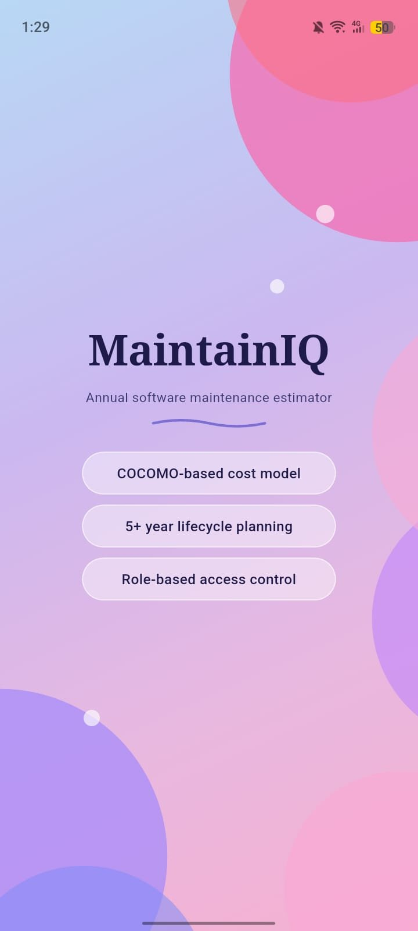  Figure 9.1b Splash Screen (Onboarding)

9.2 Login Screen

The Login screen has a clean and simple design. Soft pink and purple circles are placed in the corners, giving it a friendly and branded look. The form includes:

An Email field with a user icon

A Password field with a lock icon and an option to show or hide the password

A “Forgot Password?” link to reset the password using Firebase

A purple “Login” button

A “Continue with Google” button for quick sign-in

A “Don’t have an account? Sign Up” link to create a new account

All the security is handled by Firebase in the background. The app does not store passwords itself they are securely managed by Firebase. Users must verify their email before they can fully use the app.

9.3 Sign Up Screen
The Sign Up screen follows the same clean and simple design as the Login screen, with soft pink and purple circles in the corners. New users need to enter:

- Full Name, which is saved in their Firebase profile
- Email address, used for login and verification
- Password, which must meet Firebase’s security rules
- Confirm Password, to make sure both passwords match before submitting

After signing up, Firebase sends a verification email. Users must verify their email before they can fully use the app. This helps prevent fake accounts and keeps user information accurate. There is also an “Already have an account? Sign In” link to go back to the login screen.

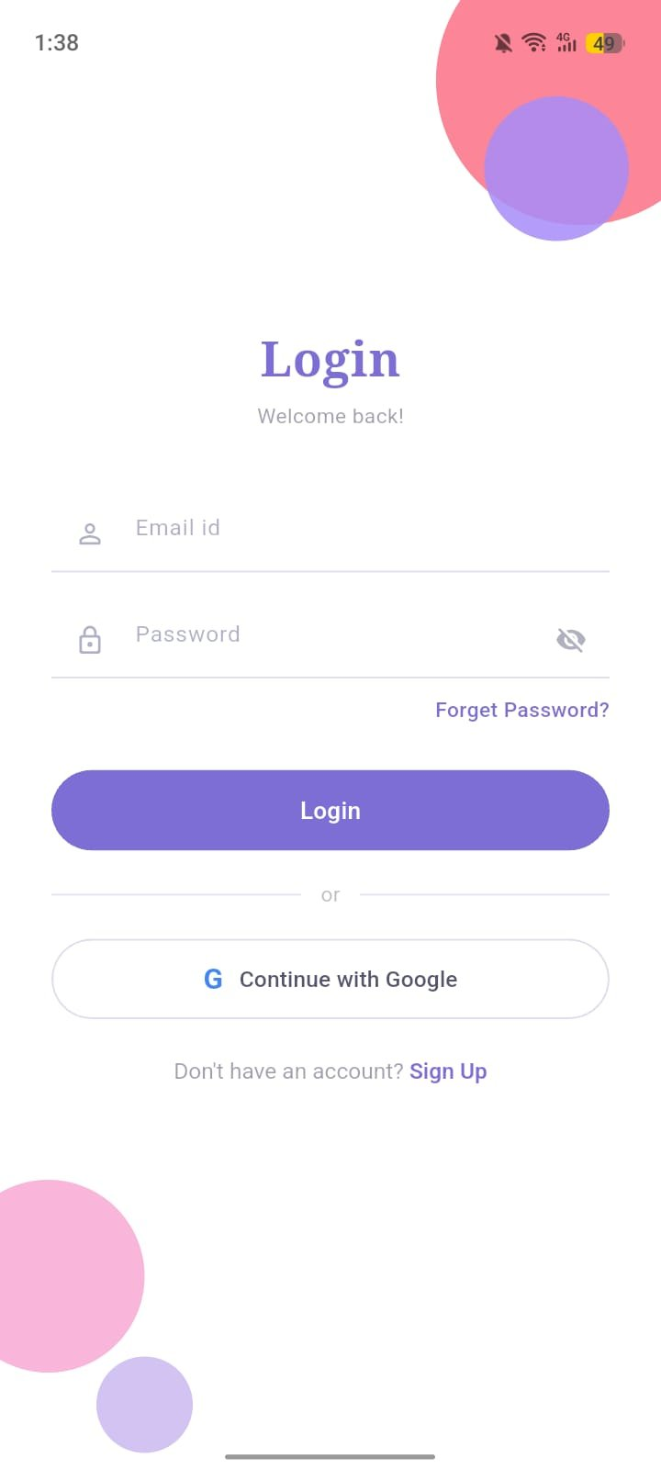  Figure 9.2 Login Screen | 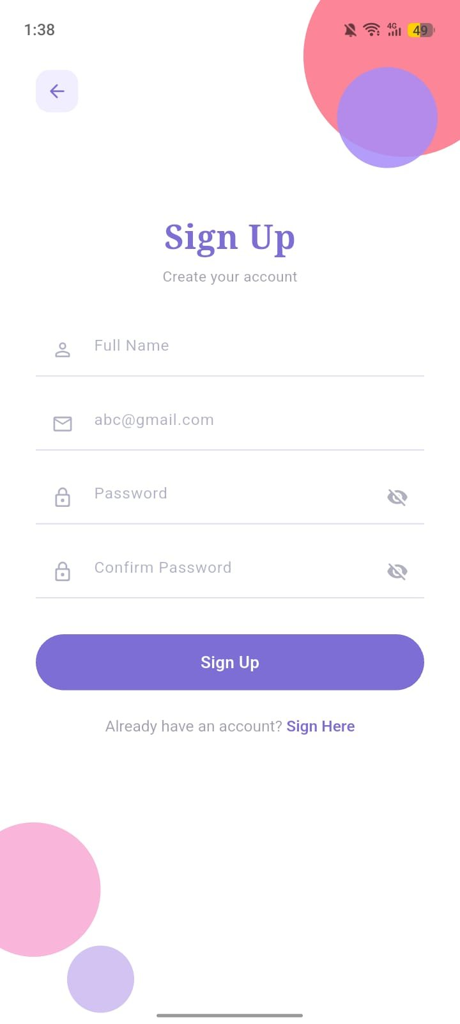  Figure 9.3 Sign Up Screen

9.4 Home Dashboard Screen
The Home Dashboard is the main screen of MaintainIQ where users can easily access everything. It welcomes the user by name (like “Hello, Rayyan”) with a subtitle “Estimate Software Cost.” The screen is divided into three parts:
- Quick Action Card: A big button that says “Create new estimate – Check software maintenance cost.” When tapped, it takes the user directly to the estimation form, which is the main feature of the app.
- Model Info Cards: Two cards placed side by side showing “COCOMO II Model Used” and “5+ Years Projection,” highlighting that the app is reliable and focuses on long-term planning.
- Features Grid: Four sections that give quick access to Cost Estimation, AI Chatbot, History, and PDF Report. Each one has an icon and a short description.
At the bottom, there is a navigation bar that allows users to move between Home, History, a center “Create Estimate” button, Insights, and Profile. This makes it easy to access any feature quickly.

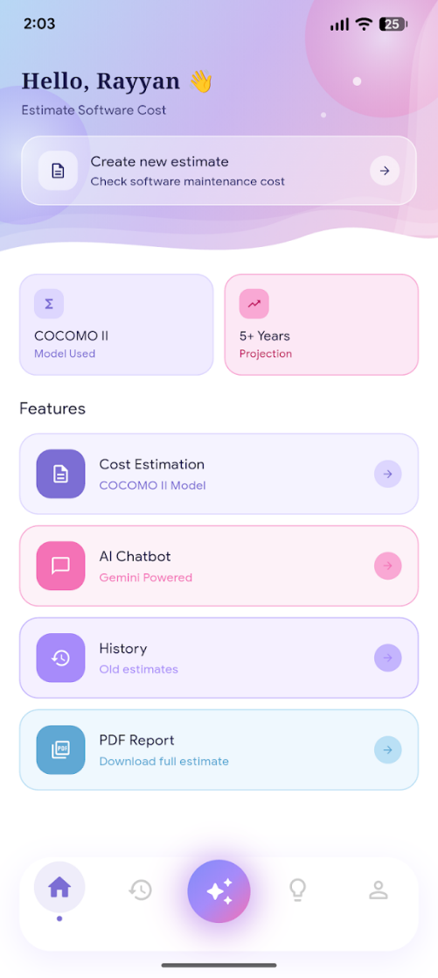
Figure 9.4 Home Dashboard Screen

9.5 History Screen
The History screen shows all previous estimates in a timeline style, with a dotted line on the left connecting each entry. Every card includes:

- Software name (for example, Airline Reservation System or University Management System)
- System size (Small / Medium / Large / Enterprise) and type (Desktop / Mobile / Web / Embedded)
- Total maintenance cost along with the time duration
- “View” and “Delete” buttons at the bottom

At the top-right, there is a USD/PKR toggle that instantly changes all costs into the selected currency. This makes it very useful for Pakistani users, as they can easily switch between USD for international use and PKR for local planning without recalculating anything.

The sample estimates visible in the screenshots demonstrate the app's ability to handle diverse system types from small desktop systems like the Airline Reservation System to large mobile systems like the University Management System each with different cost profiles.

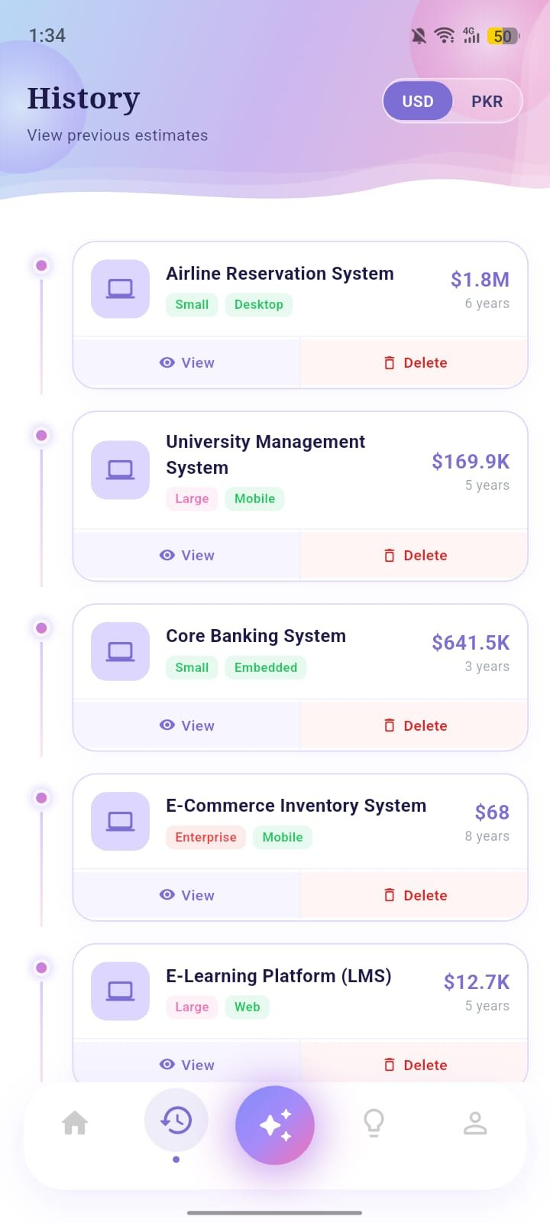  Figure 9.5a History Screen (USD) | 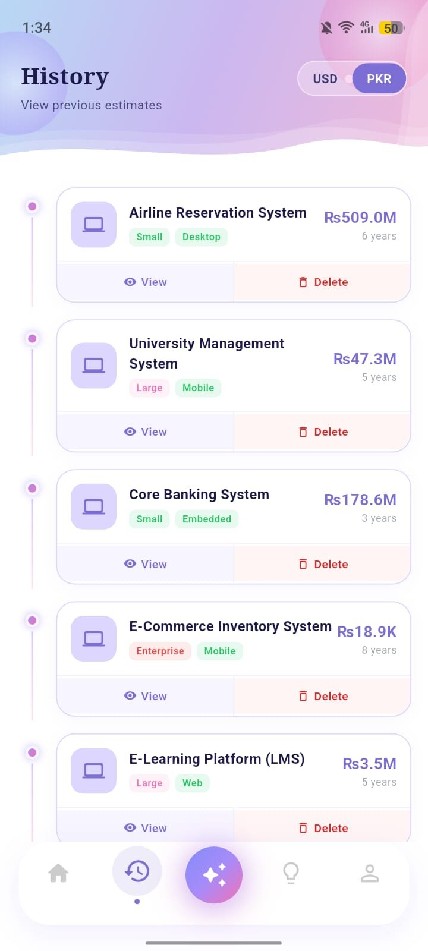  Figure 9.5b History Screen (PKR)

9.6 AI Chatbot Screen
The AI Chatbot screen provides a built-in assistant powered by Google Grok AI. The chat design is simple and familiar: AI messages appear on the left in white bubbles, while user messages appear on the right in purple bubbles.
The chatbot introduces itself as “MaintainIQ AI” and explains that it can help with software maintenance costs, the COCOMO model, technical debt, and ROI analysis. At the bottom, there are quick-reply buttons with common questions like “What is the COCOMO model?” and “How to reduce technical debt?” This helps users who may not know what to ask.
In the example shown, a user asked “what is cocomo model define in english,” and the chatbot gave a detailed explanation. It described COCOMO as a model created by Barry W. Boehm in 1981, used to estimate the cost, effort, and time needed for a software project based on its size, complexity, and team capability. The answer is clear, accurate, and easy to understand for software-related users.
The chatbot supports both English and Urdu, making it accessible to Pakistani users who prefer their native language for technical consultations. The 'Online Grok AI' status indicator confirms connectivity to the live AI backend.

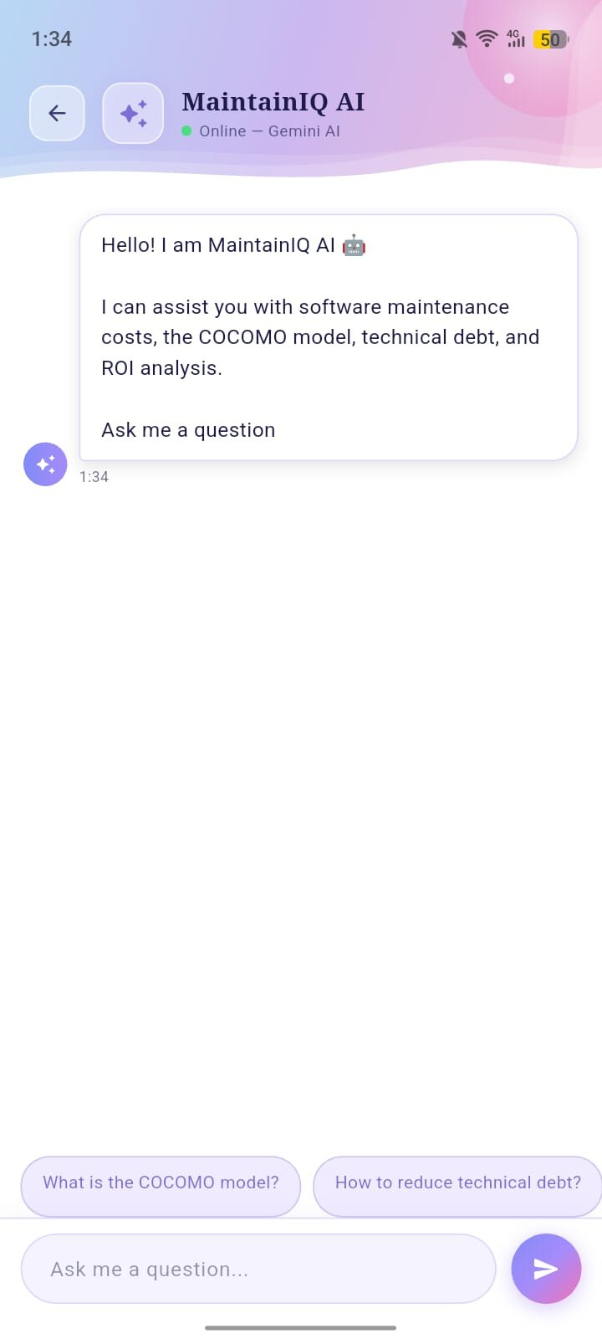  Figure 9.6a AI Chatbot (Empty) | 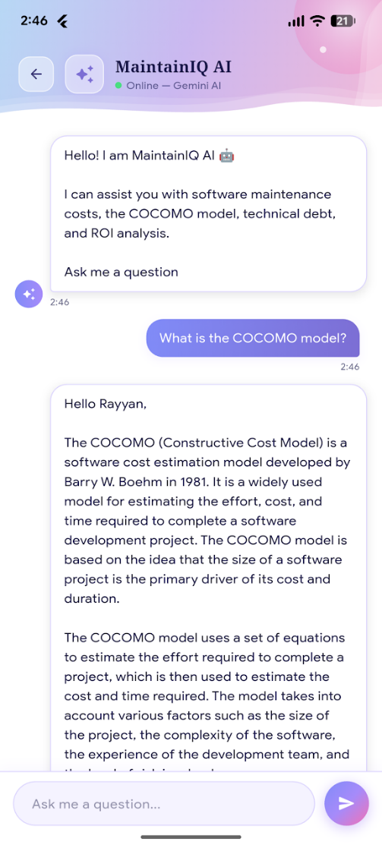  Figure 9.6b AI Chatbot (Conversation)

9.7 Insights Screen
The Insights screen is one of the most detailed parts of MaintainIQ. It is divided into different sections:

Section 1 Portfolio Statistics & Maintenance Tips
At the top, there are three summary cards that show overall stats from all user estimates:
- Total number of projects (e.g., 6)
- Average maintenance cost (e.g., $1.1M)
- Total budget across all projects (e.g., $6.5M)
These give a quick overview of the user’s overall maintenance spending.
Below that, there is a “Maintenance Tips” section with helpful advice shown in colored cards:
- Reduce Technical Debt Early: Technical debt can increase yearly maintenance cost by about 3%, so fixing issues early saves money.
- Age Factor is Real: Older software becomes more expensive—around 4% more each year. A 10-year-old system may cost about 40% more to maintain.
- Team Size vs Complexity: More complex systems need bigger teams. For every 2 points increase in complexity above 6, one extra maintenance engineer is recommended.
- When to Rebuild vs Maintain: If maintenance cost over 3 years becomes higher than the original development cost, rebuilding is usually a better option.
- Security Maintenance is Mandatory: (partially shown) highlights the importance of keeping systems secure.

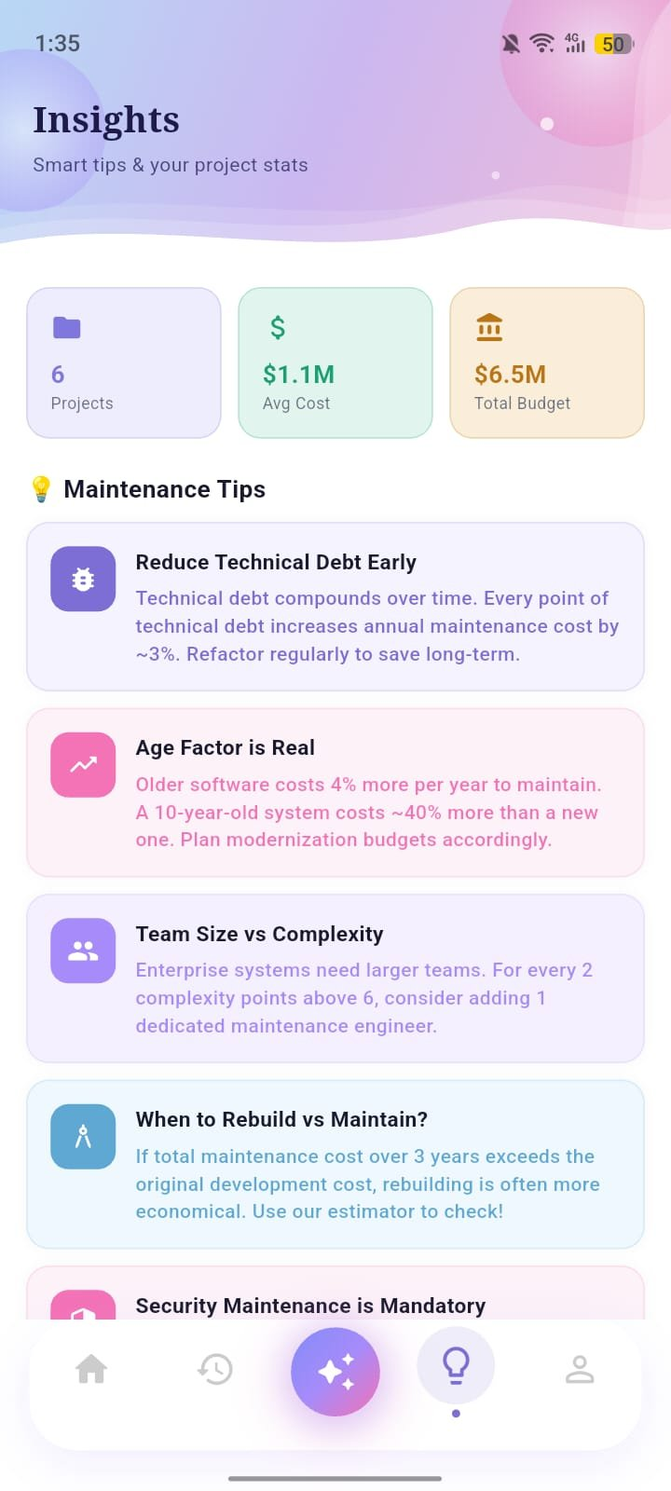
Figure 9.7a Insights Screen (Stats & Tips)
Section 2 COCOMO II Formula Reference
The second section of Insights displays the full COCOMO II formula used by the app, formatted as a code block:

Annual Maintenance Cost =
DevCost × BaseRate × SizeFactor × AgeFactor × Inflation
BaseRate = 15% + (Complexity×2.5%) + (TechDebt×3%)
AgeFactor = 1.0 + (Age × 0.04)
SizeFactor = Small=1.0 / Medium=1.3 / Large=1.6 / Enterprise=2.0
Inflation = 3% compounded per year

Section 3 — Quick Rules of Thumb & Top Estimates
The “Quick Rules of Thumb” panel shows simple, industry-based guidelines that help users make quick decisions. These rules are color-coded, so it’s easy to understand which situations are normal, warning, or critical.
Below that, the “Your Top Estimates” section highlights the three most expensive projects in the user’s list. Each project also has a status label like Critical or Healthy, helping users quickly identify which projects need more attention.

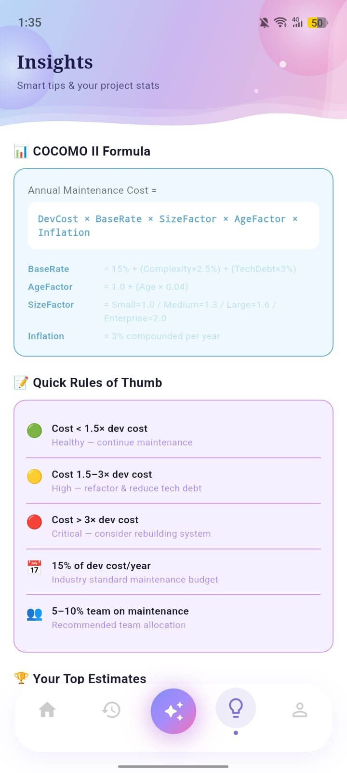  Figure 9.7b Insights (COCOMO Formula) | 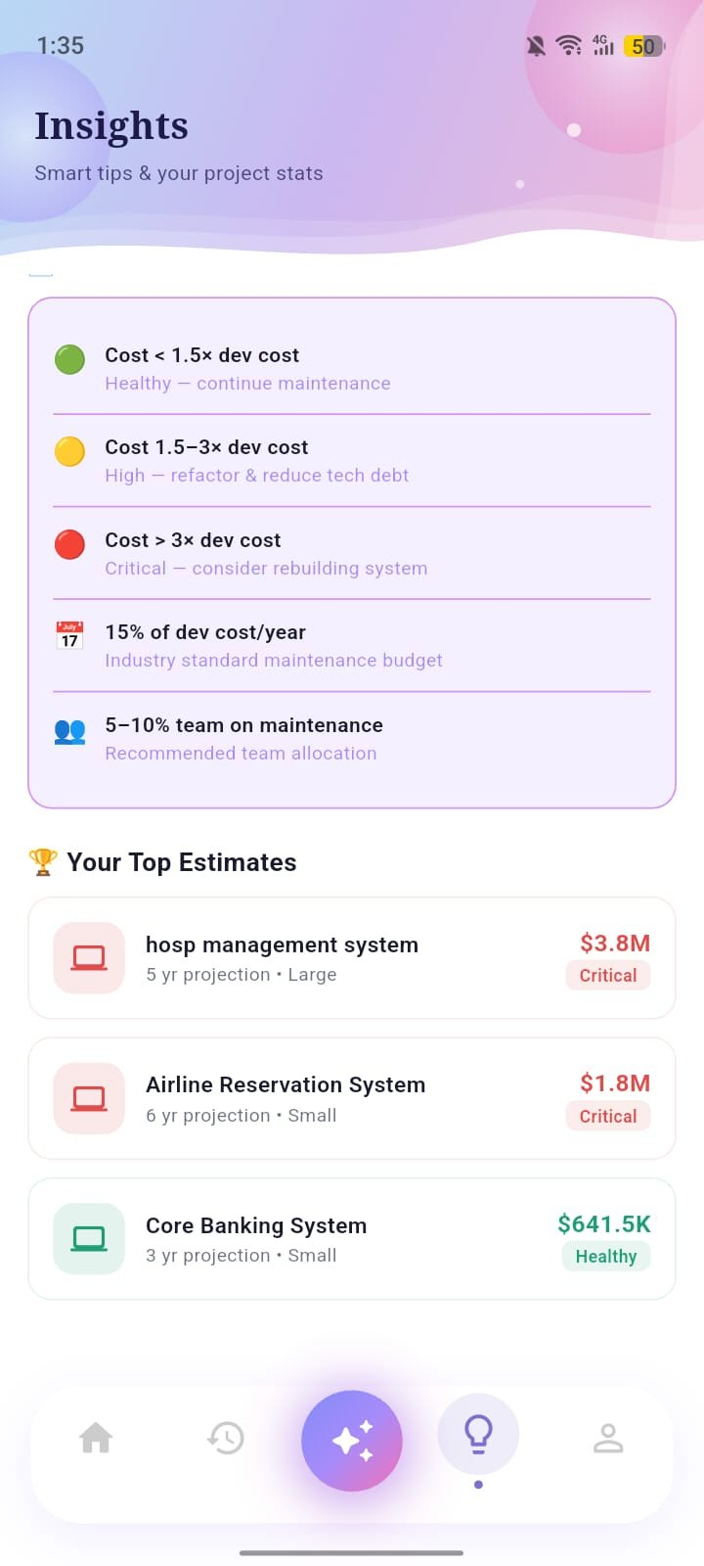  Figure 9.7c Insights (Rules & Top Estimates)
9.8 PDF Reports Screen
The PDF Reports screen shows all the estimates for which PDF reports have been created. It gives more details compared to the History screen. Each card includes:
- The software name and its total cost in the selected currency
- Tags showing the size and type of the project
- Extra details like project duration, complexity level (for example, 5/10), and team size (for example, 5 developers)
- The file name of the generated PDF report
- Buttons to “View PDF” and “Delete”
At the top-right corner, there is a USD/PKR toggle. It works the same as in the History screen and instantly changes all costs into the selected currency without creating new data.
The PDF report is already created when the estimate is made and saved on the device, so you can open it without needing the internet.
Some example projects shown are:
- Airline Reservation System ($1.8M / Rs509.0M)
- University Management System ($169.9K / Rs47.3M)
- Core Banking System ($641.5K / Rs178.6M)
- E-Commerce Inventory System ($68 / Rs18.9K)
These examples show that the app can handle both small and large projects easily.

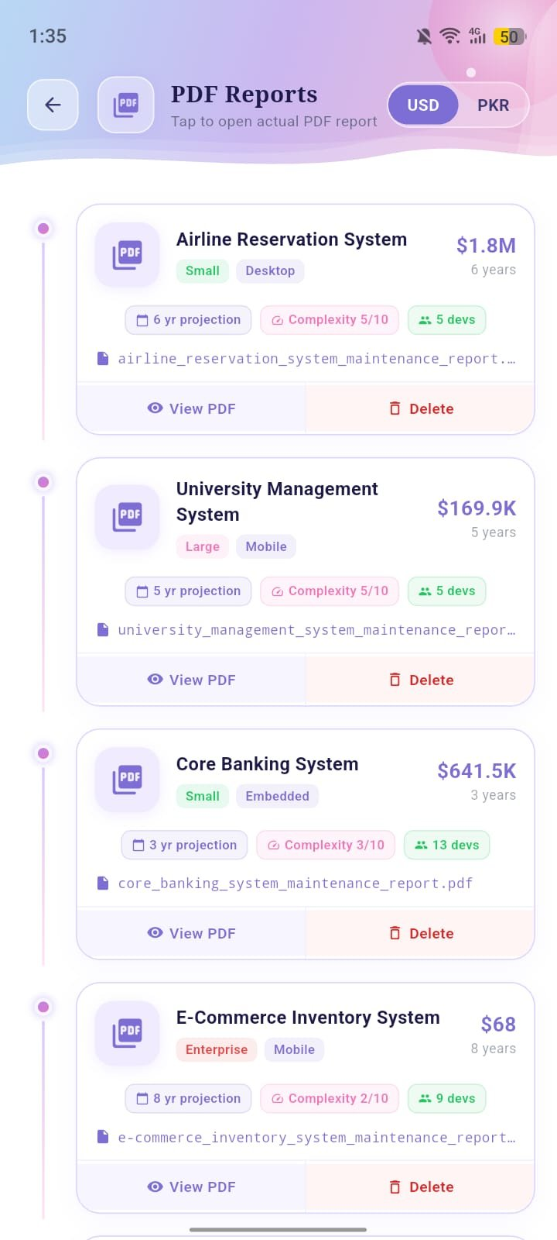  Figure 9.8a PDF Reports (USD) | 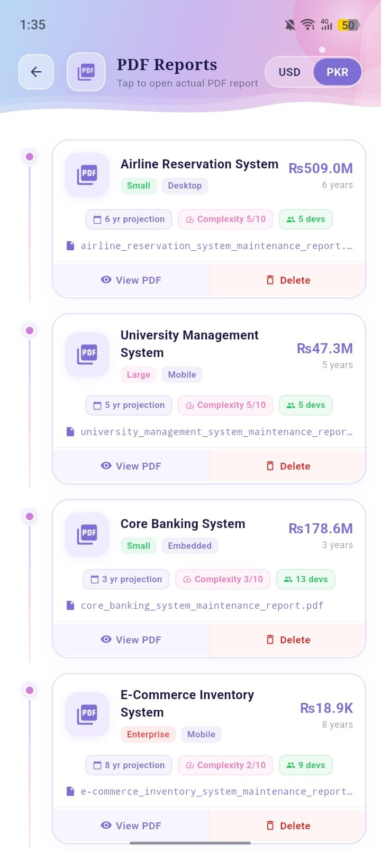  Figure 9.8b PDF Reports (PKR)
9.9 Estimation Results Screen
The Results screen is the main output screen of MaintainIQ. After applying the COCOMO II formula, it shows a detailed breakdown of the maintenance cost for the selected software project. The screen is divided into different sections:
- Total Maintenance Cost Card: A large purple card at the top that shows the total maintenance cost (for example, Rs 18.8K or $68) for the whole time period (for example, 8 years).
- Parameter Summary Chips: Three small cards that show the project details like size (Enterprise), type of software (Mobile), and age (5 years). This helps users quickly check their selected inputs.
- Year-by-Year Bar Chart: An interactive bar chart that shows the maintenance cost for each year (Year 1 to Year 8). The bars increase from left to right, showing how the cost grows over time due to factors like age and inflation.
- Yearly Cost Table: A detailed table that shows the exact cost for each year, so users can clearly see how the cost increases every year.
The example of the E-Commerce Inventory System shows that even a low-cost system ($68 / Rs 18.8K over 8 years) still has a steady increase in cost. The bar chart makes this growth easy to understand.
The USD and PKR views look the same, only the currency values change using the toggle at the top.
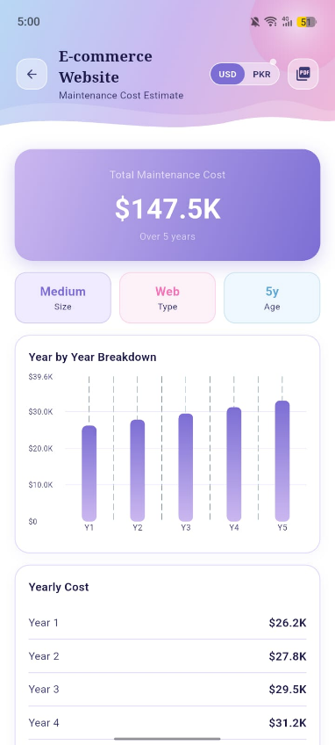  Figure 9.9a Results Screen (USD) | 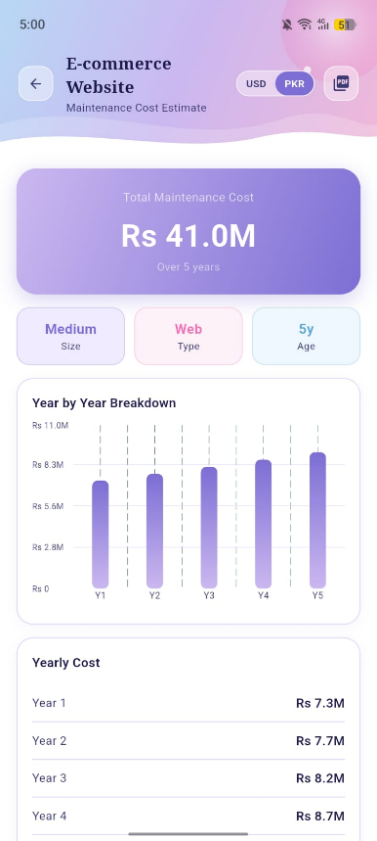  Figure 9.9b Results Screen (PKR)

9.10 Profile Screen
The Profile screen shows the user’s account details along with information about the app. It is divided into three main sections:
- User Profile Header: Shows the user’s Google profile picture, name (Bushra Waseem), email address, and an “Email Verified” badge to confirm the account is authenticated.
- App Info Section: Displays details about the app, such as the app name (MaintainIQ), version (1.0.0), model used (COCOMO II), and AI powered by (Google Grok). This helps users understand what technology the app is using.
- Account Section: Shows the user’s email and account type (Google Account), confirming how the user is logged in.
The Profile screen is also where users can log out and find “About Project” information. It helps keep everything clear so users always know which app version and AI model they are using.

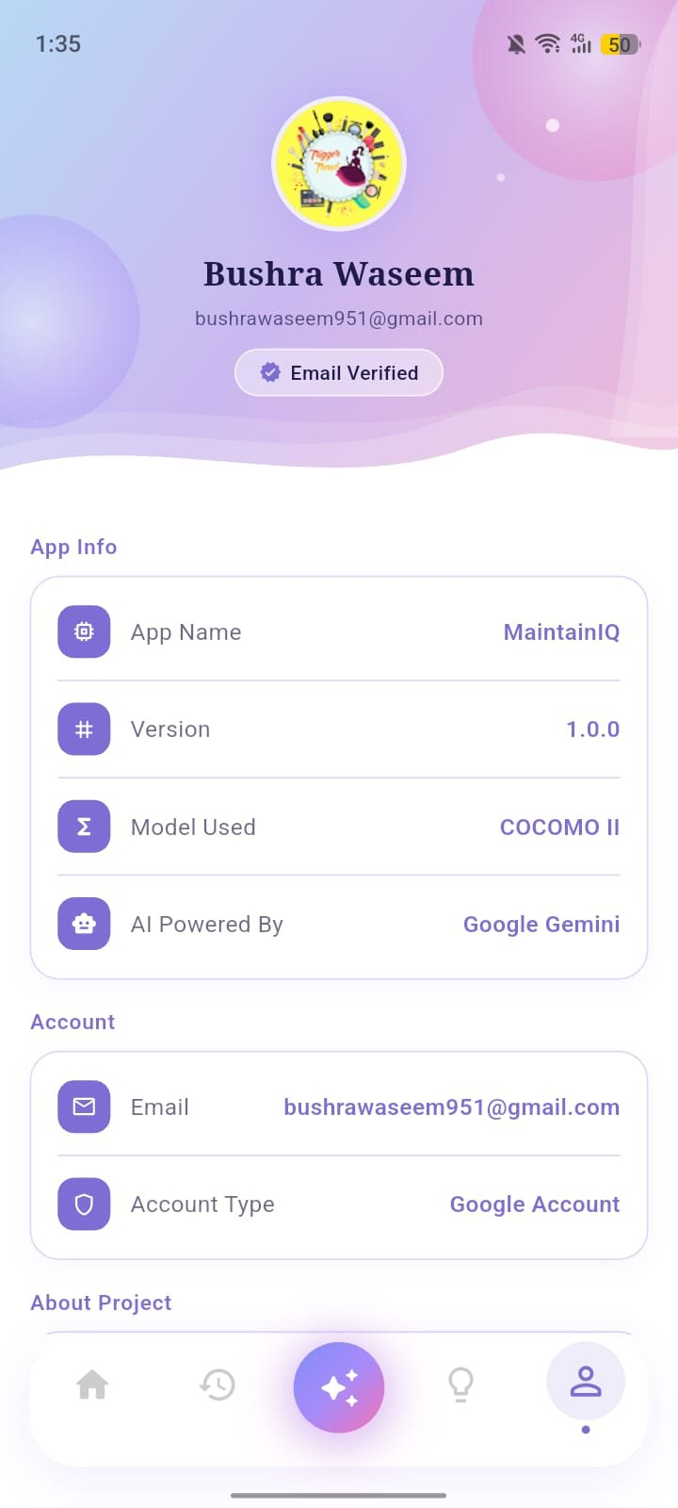
Figure 9.10 Profile Screen

9.11 Professional PDF Report Export

To help with decision-making and communication, the app includes a strong PDF generation feature.
The generated PDF is a well-formatted report that includes:
- All the input details provided by the user
- The complete COCOMO II formula used for the calculation
- A detailed year-by-year cost breakdown table
The app uses the device’s built-in print and share options. This allows users to easily save the PDF, print it, or share it with project stakeholders.

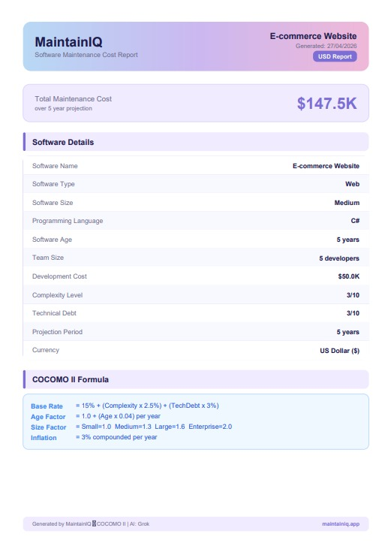  Figure 9.11a PDF report (USD) | 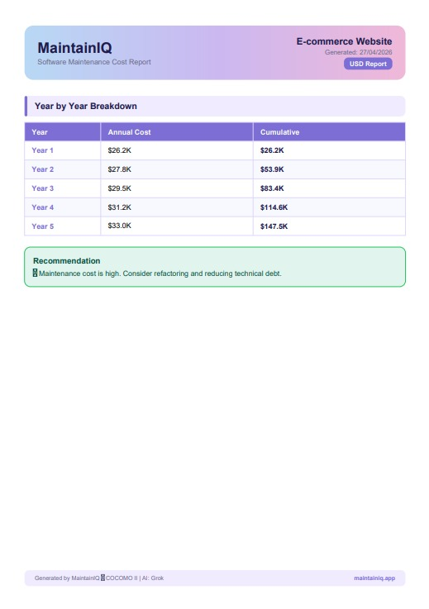  Figure 9.11b PDF report (USD)

10.0 Architecture Diagram

The MaintainIQ architecture is divided into three main layers. Each layer has its own role, so parts of the app can be updated or changed without affecting the others.

10.1 Layer 1: Flutter Mobile App (Presentation Layer)
This is the top layer where users interact with the app. It includes five main screens:
- Splash Screen (starting and loading screen)
- Login/Register Screen (for user authentication)
- Home Dashboard (main navigation area)
- Estimation Screen (where users calculate costs)
- Results/History Screen (to view results and saved records)
All user actions happen in this layer. Flutter updates the screen automatically whenever data changes, making the app responsive and smooth.

10.2 Layer 2: Services Layer (Business Logic)
This is the middle layer where the main logic of the app works. It includes five services:
- Auth Service: Handles login, logout, Google sign-in, email verification, and user sessions using Firebase Authentication.
- COCOMO Service: The main calculation engine that uses input data to apply the COCOMO II formula and calculate yearly costs.
- Firestore Service: Manages the database by saving, reading, and deleting user estimation records.
- PDF Service: Creates a professional PDF report from the data and allows users to download or share it.
- AI Service: Connects with Grok AI, sends user messages, and returns responses to show in the app.
This layered design makes the app organized, flexible, and easier to maintain.

10.3 Layer 3: Backend / Data Layer
The bottom layer includes all the external services that MaintainIQ uses.
- Firebase Authentication manages user login, identity, and session data.
- Cloud Firestore stores all estimation data and keeps it updated in real-time across devices.
- Grok AI API provides chatbot and AI-based responses.
- PDF and Printing tools handle creating and exporting documents directly on the device.
This layer supports the app by providing all the important backend and external features needed for it to work properly..

Flutter App Architecture
Flutter Mobile App (Presentation Layer)
Splash Screen | Login / Register | Home Dashboard | Estimation Screen | Results / History
↓
Services Layer (Business Logic)
Auth Service | COCOMO Service | Firestore Service | PDF Service | AI Service
↓
Backend / Data Layer (Firebase & External APIs)
Firebase Auth | Cloud Firestore | Grok AI API | PDF Package | FL Chart

Figure 10.1 MaintainIQ Three-Layer Architecture Diagram

11.0 Use Case Diagram
The use case diagram shows how the User and the Firebase system interact with the MaintainIQ app. It explains what actions the system supports and who starts each action.

11.1 Actors
- User: The main actor. This can be a project manager, student, developer, or IT consultant who uses the app on their mobile device.
- Firebase System: The secondary actor. This is an automatic system that handles login and data storage when the app sends requests on behalf of the user.

11.2 Use Cases Within the MaintainIQ System Boundary
The app supports the following main actions:
- Register / Login: The user signs in using email/password or Google. Firebase checks the details and gives access.
- Create Estimate: The user enters project details and requests a cost calculation. The app uses the COCOMO II formula to show yearly costs, system health, and recommendations.
- View History: The user can see past estimates saved in the database, linked to their account.
- Toggle Currency: The user switches between USD and PKR. The app updates the displayed values using the saved exchange rate.
- Export PDF Report: The user generates a PDF report for an estimate, which is saved on the device.
- Chat with AI: The user asks questions, and the app sends them to Grok AI and shows the response.
- View Insights: The user checks overall stats, maintenance tips, and the COCOMO II formula.
- Manage Profile: The user views account details and can log out of the app.

This diagram helps to clearly show how users and the system interact with each feature of the application.
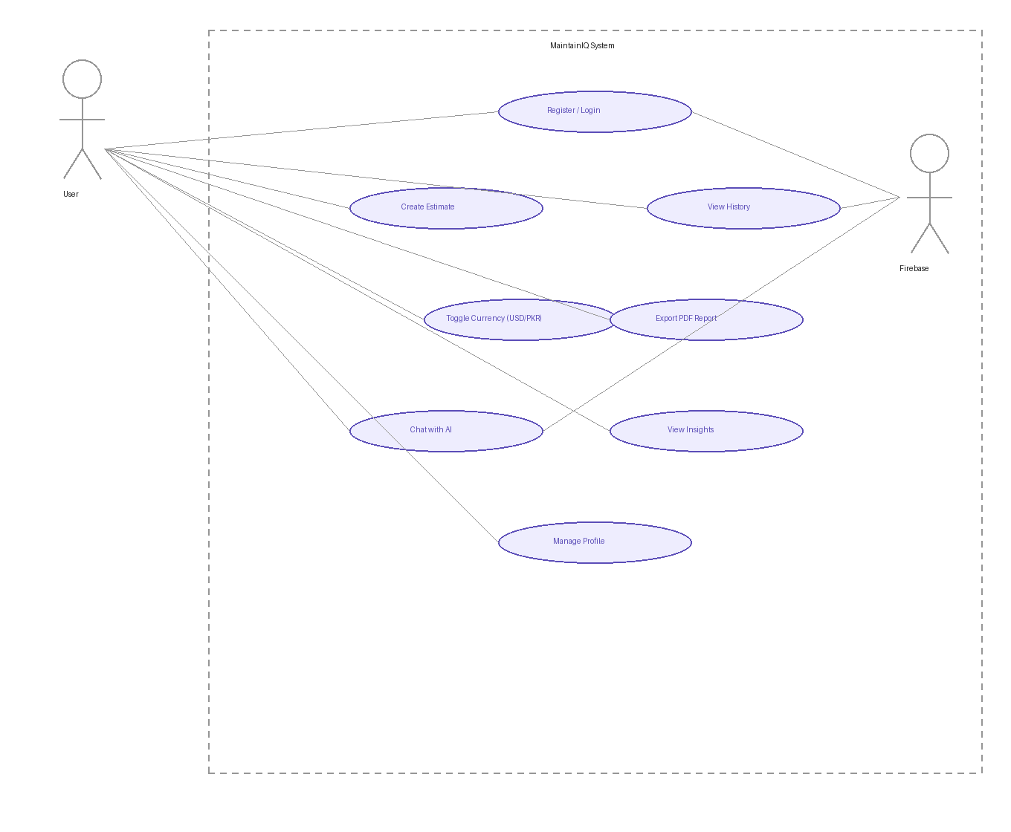
Figure 11.1 MaintainIQ Use Case Diagram

12.0 Project Folder Structure
MaintainIQ uses a standard Flutter project structure. All Dart code is placed inside the lib/ folder and divided into clear subfolders based on different parts of the app. This makes the code easy to understand, test, and update.

12.1 Root Level
maintainiq_new/: The main project folder. It includes:
- lib/ for source code
- android/ for Android settings
- assets/ for images and icons
- pubspec.yaml for managing dependencies

12.2 lib/ Directory Core Source Files
- main.dart: The starting point of the app. It sets up Firebase, starts the app, and decides which screen to open based on login status.
- firebase_options.dart: Auto-generated file with Firebase configuration details like API keys and project IDs.

12.3 constants/ App-Wide Configuration
- colors.dart: Stores all app colors (purple/pink/lavender theme) used in the UI.
- strings.dart: Contains all text used in the app, making it easier to manage and translate.

12.4 models/ Data Models
- user_model.dart: Defines the user data (ID, name, email, account type).
- estimation_model.dart: Defines all data related to a cost estimate (software name, type, size, age, yearly results, and system health).

12.5 services/ Business Logic & APIs
- auth_service.dart: Handles login, signup, Google sign-in, email verification, and logout using Firebase.
- firestore_service.dart: Manages database operations like saving, fetching, and deleting user data.
- cocomo_service.dart: Performs cost calculations using the COCOMO II formula.
- pdf_service.dart: Creates and downloads PDF reports.
- ai_service.dart: Connects with Grok AI, sends requests, and processes responses.

12.6 screens/ UI Screens
- splash_screen.dart: App loading screen
- login_screen.dart / signup_screen.dart: Login and registration screens
- home_screen.dart: Main dashboard
- estimation_screen.dart: Form to enter project details
- results_screen.dart: Shows results with charts and tables
- history_screen.dart: Shows previous estimates
- chatbot_screen.dart: AI chat interface
- insights_screen.dart: Shows stats, tips, and formula info
- pdf_reports_screen.dart: List of generated PDF reports
- notifications_screen.dart: Shows app notifications
- profile_screen.dart: Shows user info and app details

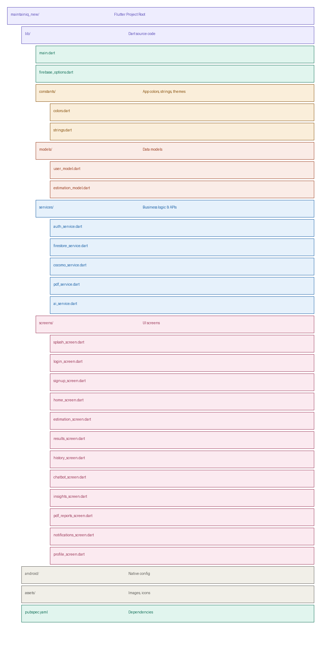
Figure 12.1 MaintainIQ Project Folder Structure
13.0 Core Features

13.1 Cost Estimation Engine

The cost estimation engine is the main part of MaintainIQ. It takes seven inputs: software name, type, size, age, development cost, complexity, and technical debt. Then it applies the COCOMO II formula to calculate the cost for each year.

The system updates the age factor every year to show how costs increase as the software gets older. Inflation is also added in a compound way, not as a fixed amount.

The results are shown in two ways:

An interactive bar chart

A detailed yearly cost table
Both are displayed in the user’s selected currency.

13.2 Health Status and Recommendation Engine

After calculating the total cost, the app compares it with the original development cost. This creates a ratio that shows the system’s health:

Less than 1.5 → Healthy

Between 1.5 and 3 → High Cost

Greater than 3 → Critical

Each level gives a clear recommendation:

Continue using the system

Refactor (improve the code)

Rebuild the system

13.3 Grok AI Chatbot

The Grok AI chatbot helps users understand the app better. It explains the COCOMO II model, results, and health status in simple terms.

It supports both English and Urdu, making it easier for Pakistani users to use the app in their preferred language.

13.4 Firebase History & Authentication

All estimates are automatically saved in Firebase Firestore and linked to the user’s account.

The History screen shows these records in a timeline. Users can log in using email/password or Google. Their data stays محفوظ even if they switch devices.

13.5 PDF Report Generation

Users can download any estimate as a professional PDF report. The report includes:

Software details

COCOMO II formula with user values

Year-by-year cost table

Health status

Final recommendation

These reports can be shared with teachers, clients, or team members.

13.6 Insights Dashboard
The Insights screen provides a portfolio view across all of a user's estimates, with aggregate statistics, maintenance tips grounded in industry research, a COCOMO II formula reference card, quick rules of thumb with color-coded thresholds, and a ranked list of the user's highest-cost projects.

14.0 COCOMO II Formula & Calculation

14.1 The Full Formula
BaseRate = 15% + (Complexity × 2.5%) + (TechDebt × 3%)
AgeFactor = 1.0 + (Age × 0.04) recalculated each year
SizeFactor: Small=1.0 Medium=1.3 Large=1.6 Enterprise=2.0
Inflation = (1.03)^n where n = projection year
AnnualCost(year n) = DevCost × BaseRate × SizeFactor × AgeFactor(n) × (1.03)^n

14.2 Worked Example
Using a Medium-sized, 3-year-old JavaScript web application with Complexity = 5 and Technical Debt = 5, with an original development cost of $2,000:

Step | Calculation
BaseRate | 15% + (5×2.5%) + (5×3%) = 15% + 12.5% + 15% = 42.5%
SizeFactor | 1.3 (Medium)
AgeFactor (Year 1) | 1.0 + (3 × 0.04) = 1.12
Inflation (Year 1) | 1.03^1 = 1.03
Year 1 Cost | $2,000 × 0.425 × 1.3 × 1.12 × 1.03 ≈ $1,276 (~$1.3K)
5-Year Total | $7,500 | Ratio = 3.75× | Status = CRITICAL → Rebuild

15.0 Software Quality Assurance
The application was validated through eight functional test cases covering all critical system behaviors. Each test was run manually on a physical Android device.

# | Test Case | Expected Result | Result | Type
1 | Valid estimation input submitted | Correct year-by-year costs displayed | ✅ PASS | Functional
2 | Empty fields submitted | Validation error shown; submission blocked | ✅ PASS | Validation
3 | Critical project (ratio > 3×) | Critical badge and rebuild recommendation shown | ✅ PASS | Classification
4 | Healthy project (ratio < 1.5×) | Healthy badge and continue recommendation shown | ✅ PASS | Classification
5 | PDF report generation | PDF downloaded with correct data | ✅ PASS | Export
6 | Firebase history save and retrieve | Estimate saved and visible in History | ✅ PASS | Integration
7 | Google Sign-In authentication | User authenticated and redirected to Home | ✅ PASS | Auth
8 | USD / PKR currency toggle | All values correctly converted and displayed | ✅ PASS | UI/UX

All eight test cases passed. The application handled correct inputs, invalid inputs, third-party integrations, and export functionality without errors. The COCOMO II calculation was verified against manual computations for each test case to confirm mathematical accuracy.

16.0 Limitations
The following limitations exist in the current version (1.0.0) and should be understood before drawing conclusions from the tool's output:

Limitation | Explanation
Manual Input Only | MaintainIQ requires users to assess and enter complexity and technical debt ratings subjectively. It does not analyze source code. The quality of estimates depends on the accuracy of user inputs.
Simplified COCOMO II | The implementation uses a maintenance-focused adaptation of COCOMO II. The full model includes additional scale factors and effort multipliers not captured here. Results should be treated as directional estimates, not precise financial forecasts.
No Real-Time Economic Data | Inflation is fixed at 3% per year a reasonable historical average but potentially inaccurate in high-inflation periods or specific regional markets.
Single-User Only | The current version does not support team collaboration. Multiple team members cannot contribute to or share a single estimate simultaneously.
Android Only | The current release targets Android. iOS support, while technically feasible with Flutter, was not completed within the project timeline.

17.0 Conclusion

Software maintenance costs are often underestimated in organizations. When teams don’t plan properly or base their estimates on the real needs of their systems, they can face budget problems, delayed maintenance, and growing technical issues. Over time, keeping the system running can become more expensive than rebuilding it from scratch.

MaintainIQ doesn’t solve every problem, but it focuses on the most important one: helping organizations see the problem early. It provides clear estimates using the COCOMO II model in a simple mobile app. Anyone with an Android device can use it for free, without needing special training.

The app includes all the planned features, such as cost estimation based on COCOMO II, system health status, AI assistance, Firebase-based history and login, PDF report export, and support for both USD and PKR currencies. All test cases were successfully passed, and the results are reliable and useful for decision-making.

Beyond the technical side, this project shows what a small, well-organized team can achieve in a short time when working on a meaningful problem. By combining mobile development, mathematical models, cloud services, and AI into one app, Group 13 created a strong and practical engineering solution.

18.0 Future Work
Several directions for future development have been identified based on the limitations of the current version and feedback from testing:

Enhancement | Description
iOS Support | Flutter supports iOS compilation from the same codebase. Extending the release to iOS would significantly expand the application's reach beyond Android users.
Real-Time Inflation Data | Connecting to an economic data API (e.g., World Bank or a forex API) would allow the inflation factor to reflect current market conditions rather than a fixed 3% historical average.
Source Code Analysis | Integrating static analysis tools would allow the application to automatically assess complexity and technical debt from a code repository, reducing reliance on subjective user input.
Team Collaboration | Shared project workspaces would allow multiple team members to contribute to and review estimates together, reflecting how maintenance planning actually happens in organizations.
Full COCOMO II Model | The complete COCOMO II model includes additional scale factors and effort multipliers that would improve precision for complex, large-scale enterprise systems.
Multi-Currency Support | Expanding beyond USD and PKR to support additional global currencies would make the tool useful to a broader international audience.
Web Version | A browser-based version of MaintainIQ would make it accessible without requiring an app installation, significantly lowering the barrier to adoption.

References
- Boehm, B. W. (1981). Software Engineering Economics. Englewood Cliffs, NJ: Prentice-Hall.

- Boehm, B., Abts, C., Brown, A. W., Chulani, S., Clark, B. K., Horowitz, E., Madachy, R., Reifer, D., & Steece, B. (2000). Software Cost Estimation with COCOMO II. Upper Saddle River, NJ: Prentice-Hall.

- Pigoski, T. M. (1996). Practical Software Maintenance: Best Practices for Managing Your Software Investment. New York, NY: Wiley.

- Lehman, M. M. (1980). Programs, Life Cycles, and Laws of Software Evolution. Proceedings of the IEEE, 68(9), 1060–1076.

- Google. (2023). Flutter Documentation. Retrieved from https://flutter.dev/docs

- Google. (2023). Firebase Documentation. Retrieved from https://firebase.google.com/docs

- Google. (2024). Grok AI. Retrieved from https://ai.google.dev

- pub.dev. (2024). fl_chart package. Retrieved from https://pub.dev/packages/fl_chart

- pub.dev. (2024). pdf package. Retrieved from https://pub.dev/packages/pdf

MaintainIQ | Group 13 | BS Computer Science | DUET | 2026
Mathematical Model: COCOMO II | AI Integration: Grok AI | Platform: Flutter

